Ideation Phase
Brainstorm & Idea Prioritization Template

Date | 18 June 2026
Team ID | -
Project Name | HouseHunt
Maximum Marks | 4 Marks

Developer Details and Selection the Problem Statement
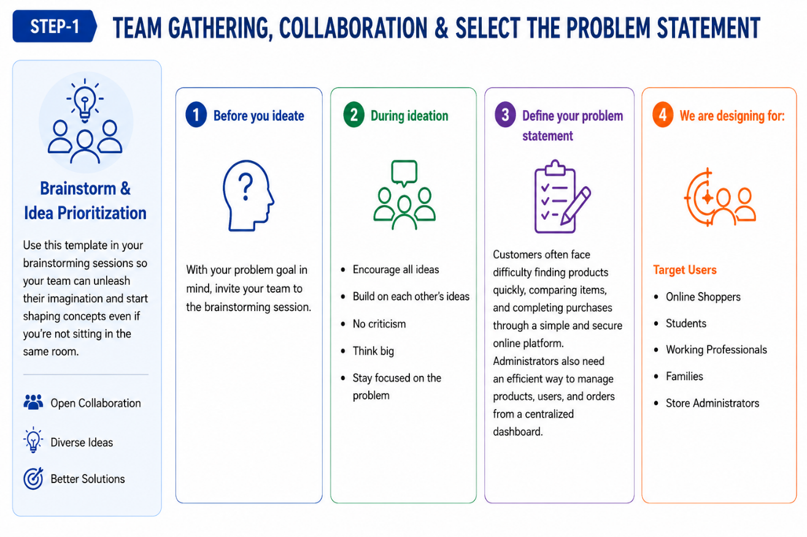

Brainstorm, Idea Listing and Grouping

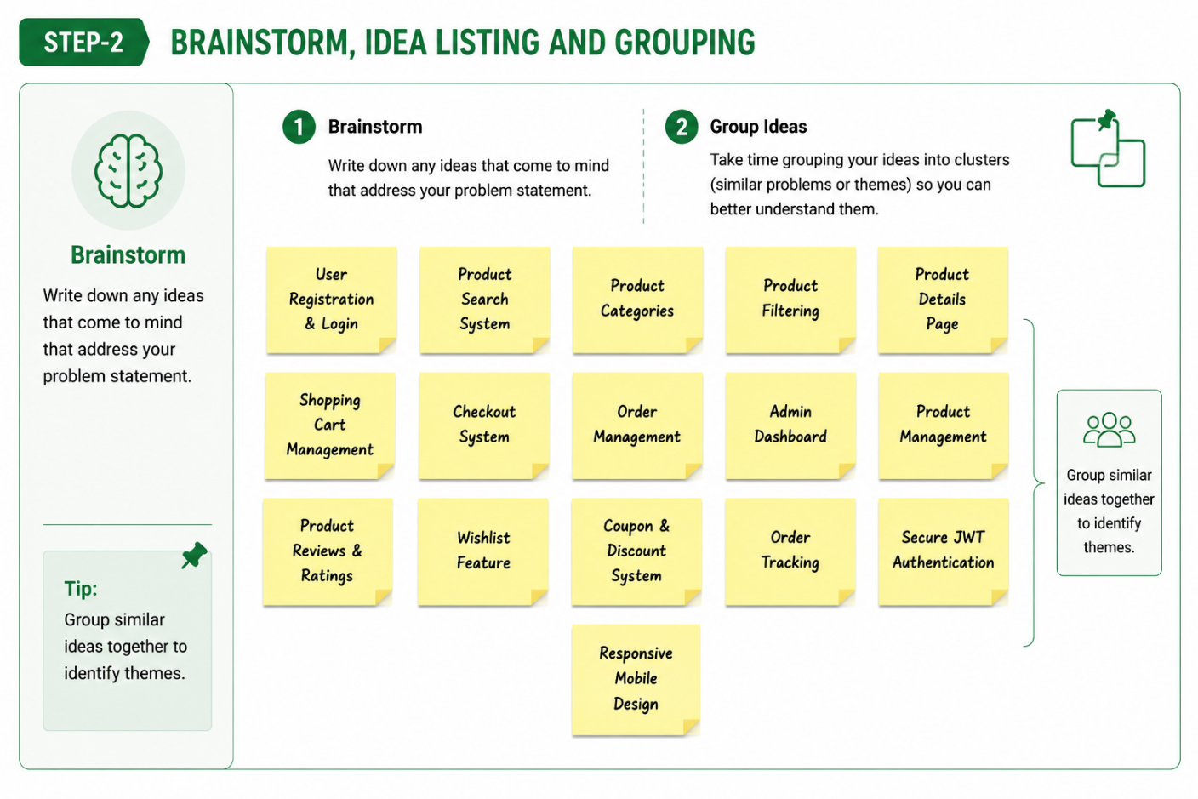
Idea Prioritization
